BỘ CÔNG THƯƠNG
TRƯỜNG ĐẠI HỌC CÔNG NGHIỆP TP. HỒ CHÍ MINH
KHOA CÔNG NGHỆ ĐIỆN TỬ
------



TIỂU LUẬN

Đề tài: Thực hành buổi 10

Giảng viên hướng dẫn: | Lê Văn Hùng
Họ tên: | Trần Tiến
Mã số sinh viên: | 22653991
Lớp: | DHMT18CTT

Tp. Hồ Chí Minh, ngày 08 tháng 04 năm 2026

Ví dụ
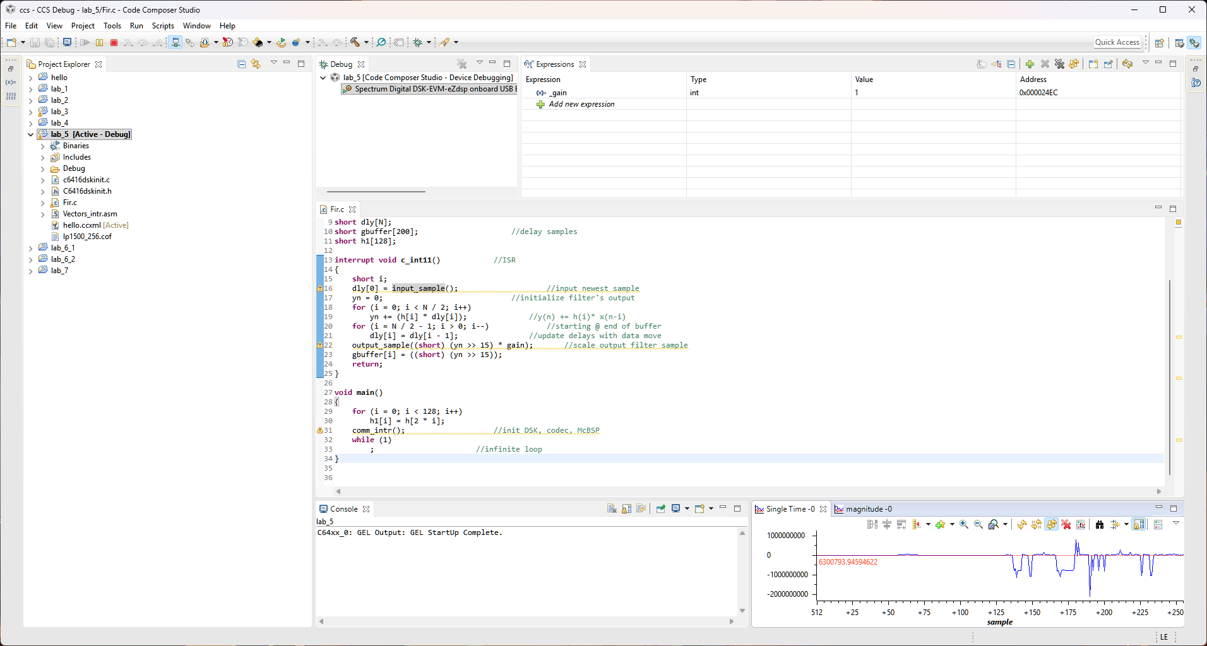
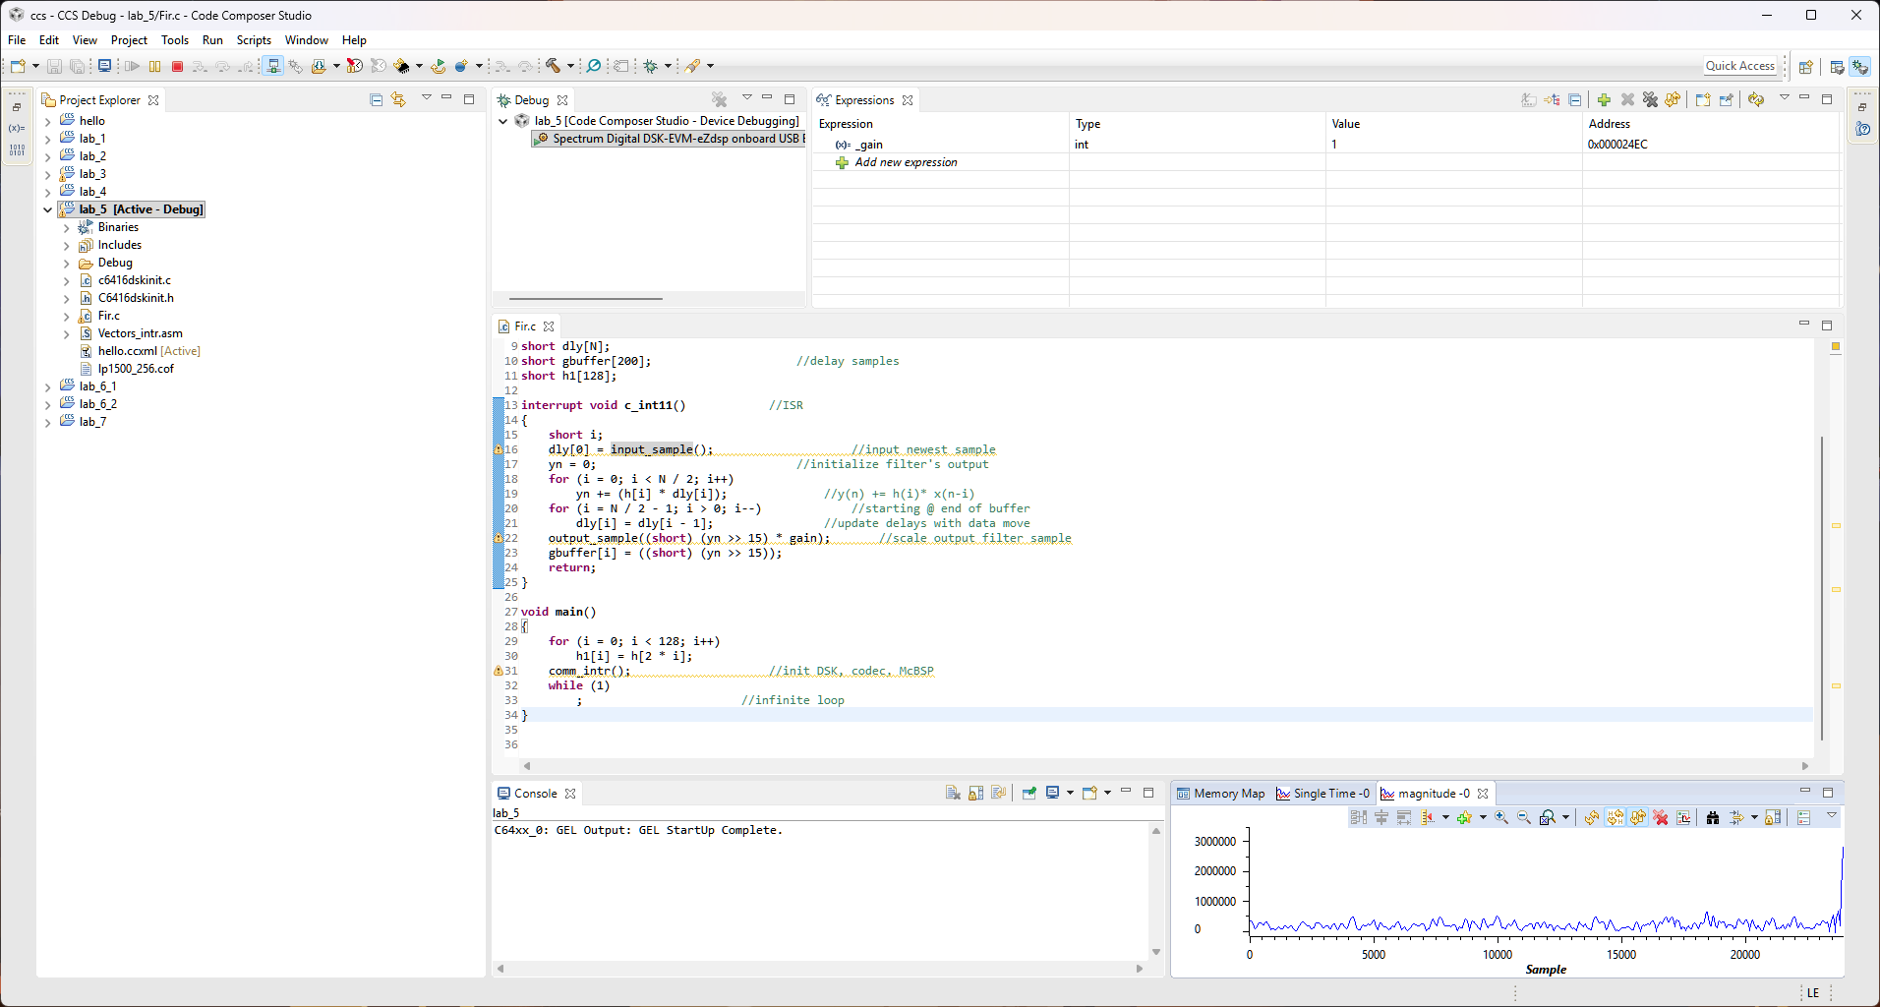

Bài tập

Bộ lọc:
#define N

short h[N]= {
0, -1, -2, -2, -2, -2, -1, 0, 0, 1, 2, 3, 3, 2, 2, 1, -1, -2, -3, -4,
-4, -3, -2, -1, 1, 3, 4, 6, 6, 5, 4, 1, -1, -4, -7, -8, -9, -8, -5, -2,
2, 6, 9, 12, 12, 11, 7, 3, -3, -8, -13, -16, -17, -15, -10, -4, 4, 12, 18, 22,
23, 20, 14, 5, -5, -16, -24, -30, -31, -27, -19, -7, 7, 21, 32, 40, 41, 36, 25, 9,
-9, -28, -43, -53, -55, -48, -33, -12, 13, 37, 58, 71, 74, 65, 45, 16, -17, -51, -79, -98,
-102, -91, -63, -23, 24, 73, 115, 144, 152, 136, 97, 36, -39, -119, -191, -245, -267, -248, -184, -72,
82, 271, 480, 692, 891, 1059, 1180, 1243, 1243, 1180, 1059, 891, 692, 480, 271, 82, -72, -184, -248, -267,
-245, -191, -119, -39, 36, 97, 136, 152, 144, 115, 73, 24, -23, -63, -91, -102, -98, -79, -51, -17,
16, 45, 65, 74, 71, 58, 37, 13, -12, -33, -48, -55, -53, -43, -28, -9, 9, 25, 36, 41,
40, 32, 21, 7, -7, -19, -27, -31, -30, -24, -16, -5, 5, 14, 20, 23, 22, 18, 12, 4,
-4, -10, -15, -17, -16, -13, -8, -3, 3, 7, 11, 12, 12, 9, 6, 2, -2, -5, -8, -9,
-8, -7, -4, -1, 1, 4, 5, 6, 6, 4, 3, 1, -1, -2, -3, -4, -4, -3, -2, -1,
1, 2, 2, 3, 3, 2, 1, 0, 0, -1, -2, -2, -2, -2, -1, 0
};

Bộ lọc
#define N 256

short h[N]= {
0, 0, 0, -1, -1, -1, -1, -2, -2, -2, -2, -2, -3, -3, -3, -3, -3, -3, -4, -4,
-4, -4, -4, -3, -3, -3, -3, -2, -2, -2, -1, 0, 0, 1, 2, 3, 4, 5, 6, 7,
8, 9, 10, 11, 12, 13, 13, 14, 15, 15, 15, 16, 16, 15, 15, 14, 14, 13, 11, 10,
8, 6, 4, 1, -1, -4, -7, -10, -13, -17, -20, -24, -27, -30, -34, -37, -39, -42, -45, -47,
-48, -50, -50, -51, -50, -50, -48, -46, -43, -40, -36, -31, -25, -19, -12, -4, 4, 13, 23, 34,
45, 56, 68, 80, 93, 106, 119, 133, 146, 159, 173, 186, 199, 211, 224, 235, 246, 257, 266, 275,
284, 291, 297, 302, 307, 310, 312, 313, 313, 312, 310, 307, 302, 297, 291, 284, 275, 266, 257, 246,
235, 224, 211, 199, 186, 173, 159, 146, 133, 119, 106, 93, 80, 68, 56, 45, 34, 23, 13, 4,
-4, -12, -19, -25, -31, -36, -40, -43, -46, -48, -50, -50, -51, -50, -50, -48, -47, -45, -42, -39,
-37, -34, -30, -27, -24, -20, -17, -13, -10, -7, -4, -1, 1, 4, 6, 8, 10, 11, 13, 14,
14, 15, 15, 16, 16, 15, 15, 15, 14, 13, 13, 12, 11, 10, 9, 8, 7, 6, 5, 4,
3, 2, 1, 0, 0, -1, -2, -2, -2, -3, -3, -3, -3, -4, -4, -4, -4, -4, -3, -3,
-3, -3, -3, -3, -2, -2, -2, -2, -2, -1, -1, -1, -1, 0, 0, 0
};

Bộ lọc
#define N 256 /*length of filter*/

short h[N]= {
0, 0, -1, -1, -1, 0, 1, 3, 3, 2, 0, -3, -5, -5, -3, 1, 5, 7, 6, 2,
-2, -6, -7, -5, -1, 3, 5, 5, 3, 0, -1, -1, 1, 1, 0, -4, -7, -8, -5, 3,
12, 17, 16, 7, -8, -21, -27, -21, -6, 13, 28, 31, 21, 2, -17, -27, -26, -14, 1, 13,
16, 11, 3, -1, 2, 8, 12, 7, -9, -28, -40, -35, -11, 27, 60, 72, 52, 6, -49, -88,
-91, -55, 7, 67, 99, 89, 43, -18, -65, -80, -59, -20, 16, 32, 24, 6, -2, 12, 42, 66,
59, 7, -76, -152, -176, -118, 16, 175, 287, 286, 153, -73, -299, -422, -372, -151, 158, 427, 532, 414,
111, -257, -533, -593, -404, -41, 347, 593, 593, 347, -41, -404, -593, -533, -257, 111, 414, 532, 427, 158,
-151, -372, -422, -299, -73, 153, 286, 287, 175, 16, -118, -176, -152, -76, 7, 59, 66, 42, 12, -2,
6, 24, 32, 16, -20, -59, -80, -65, -18, 43, 89, 99, 67, 7, -55, -91, -88, -49, 6, 52,
72, 60, 27, -11, -35, -40, -28, -9, 7, 12, 8, 2, -1, 3, 11, 16, 13, 1, -14, -26,
-27, -17, 2, 21, 31, 28, 13, -6, -21, -27, -21, -8, 7, 16, 17, 12, 3, -5, -8, -7,
-4, 0, 1, 1, -1, -1, 0, 3, 5, 5, 3, -1, -5, -7, -6, -2, 2, 6, 7, 5,
1, -3, -5, -5, -3, 0, 2, 3, 3, 1, 0, -1, -1, -1, 0, 0
};

Bộ lọc
//Fir.c FIR filter with the C6416 DSK. Include coefficient file
//Polling mode version - converted from interrupt-driven ngat.c
#include "lp1500_256.cof" //coefficient file
//#include "lp_chuan.h"
#include "dsk6416_aic23.h" //codec-dsk support file
Uint32 fs = DSK6416_AIC23_FREQ_48KHZ; //set sampling rate
int yn = 0; //initialize filter's output
int i;
int gain = 1;
short dly[N];
short gbuffer[200]; //delay samples
short h1[128];

void process_sample() //FIR filter processing function (polling)
{
short i;
dly[0] = input_sample(); //input newest sample
yn = 0; //initialize filter's output
for (i = 0; i < N / 2; i++)
yn += (h[i] * dly[i]); //y(n) += h(i)* x(n-i)
for (i = N / 2 - 1; i > 0; i--) //starting @ end of buffer
dly[i] = dly[i - 1]; //update delays with data move
output_sample((short) (yn >> 15) * gain); //scale output filter sample
gbuffer[i] = ((short) (yn >> 15));
return;
}

void main()
{
for (i = 0; i < 128; i++)
h1[i] = h[2 * i];
comm_poll(); //init DSK, codec, McBSP (polling mode)
while (1)
{
process_sample(); //continuously poll and process samples
}
}

Bộ lọc
#define N 256 /*length of filter*/

short h[N]= {
0, 1, 1, 1, 0, -1, -2, -3, -3, -3, -1, 1, 4, 5, 6, 4, 2, -2, -5, -7,
-7, -5, -2, 2, 5, 6, 5, 3, 1, -1, -1, -1, 1, 2, 1, -1, -5, -9, -11, -9,
-4, 5, 14, 21, 23, 18, 7, -7, -21, -29, -30, -22, -8, 8, 21, 28, 26, 18, 6, -5,
-11, -11, -7, -2, 1, -2, -10, -20, -26, -24, -10, 12, 38, 59, 65, 52, 20, -22, -63, -90,
-93, -70, -26, 26, 71, 96, 93, 65, 22, -21, -51, -60, -49, -27, -6, 2, -6, -26, -45, -48,
-23, 29, 96, 155, 180, 150, 62, -69, -207, -308, -334, -263, -103, 109, 316, 454, 476, 363, 138, -143,
-401, -562, -574, -428, -159, 160, 441, 605, 605, 441, 160, -159, -428, -574, -562, -401, -143, 138, 363, 476,
454, 316, 109, -103, -263, -334, -308, -207, -69, 62, 150, 180, 155, 96, 29, -23, -48, -45, -26, -6,
2, -6, -27, -49, -60, -51, -21, 22, 65, 93, 96, 71, 26, -26, -70, -93, -90, -63, -22, 20,
52, 65, 59, 38, 12, -10, -24, -26, -20, -10, -2, 1, -2, -7, -11, -11, -5, 6, 18, 26,
28, 21, 8, -8, -22, -30, -29, -21, -7, 7, 18, 23, 21, 14, 5, -4, -9, -11, -9, -5,
-1, 1, 2, 1, -1, -1, -1, 1, 3, 5, 6, 5, 2, -2, -5, -7, -7, -5, -2, 2,
4, 6, 5, 4, 1, -1, -3, -3, -3, -2, -1, 0, 1, 1, 1, 0
};

Bộ lọc
#define N 256 /*length of filter*/

short h[N]= {
0, -1, -2, -3, -2, 0, 2, 4, 4, 3, 0, -3, -3, -2, -1, 0, 0, -2, -3, -2,
2, 6, 8, 7, 2, -4, -9, -9, -5, 0, 2, 1, -1, -2, 0, 7, 13, 14, 8, -4,
-16, -21, -17, -6, 5, 10, 8, 2, -1, 4, 13, 21, 18, 2, -20, -37, -38, -22, 3, 23,
29, 21, 7, -1, 4, 16, 23, 12, -16, -48, -65, -53, -14, 32, 62, 61, 35, 3, -15, -9,
9, 16, -3, -45, -84, -91, -51, 24, 97, 128, 102, 36, -31, -61, -47, -12, 3, -24, -81, -124,
-106, -13, 121, 225, 237, 140, -16, -149, -193, -139, -45, 7, -29, -124, -181, -102, 135, 439, 633, 556,
164, -413, -913, -1072, -761, -79, 686, 1184, 1184, 686, -79, -761, -1072, -913, -413, 164, 556, 633, 439, 135,
-102, -181, -124, -29, 7, -45, -139, -193, -149, -16, 140, 237, 225, 121, -13, -106, -124, -81, -24, 3,
-12, -47, -61, -31, 36, 102, 128, 97, 24, -51, -91, -84, -45, -3, 16, 9, -9, -15, 3, 35,
61, 62, 32, -14, -53, -65, -48, -16, 12, 23, 16, 4, -1, 7, 21, 29, 23, 3, -22, -38,
-37, -20, 2, 18, 21, 13, 4, -1, 2, 8, 10, 5, -6, -17, -21, -16, -4, 8, 14, 13,
7, 0, -2, -1, 1, 2, 0, -5, -9, -9, -4, 2, 7, 8, 6, 2, -2, -3, -2, 0,
0, -1, -2, -3, -3, 0, 3, 4, 4, 2, 0, -2, -3, -2, -1, 0
};

